How to Submit an RSO Spending Request on Mason360

- Open the web browser of your choice.

- Go to the Mason360 homepage (https://mason360.gmu.edu/) and click “Sign In” in the upper
right

hand

corner.

- Sign in using your Mason credentials (Net ID and password). You may also need to set up a secure connection, using the VPN two‐factor authentication
(https://its.gmu.edu/service/virtual‐private‐network‐vpn/).

- Click on the “Groups” drop‐down menu and type your RSO name in the “Search Groups” field or 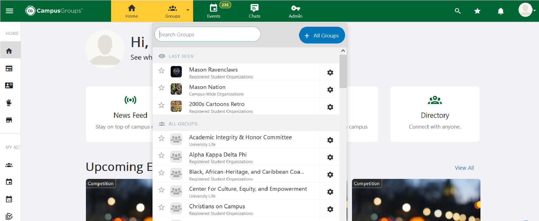scroll through the menu to find and select your RSO.

- When you are on your RSO’s profile page, either scroll down to find and click on “Budget” – OR – select the menu icon (upper left hand corner) to open up your RSO’s “Group Section.” From 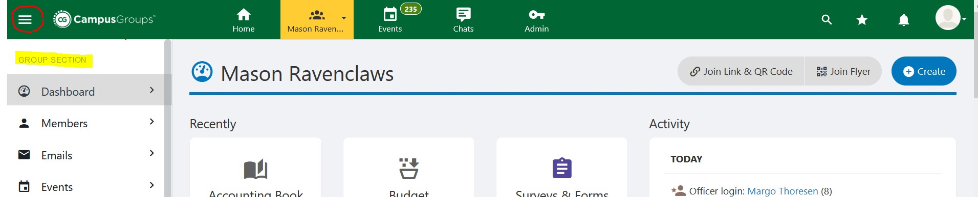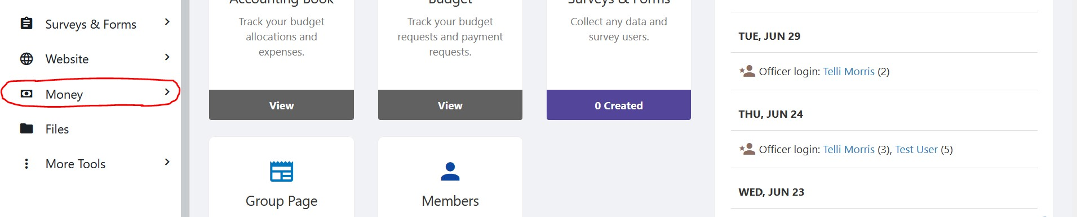the “Group Section,” select “Money” and then “Budget.”

- On your RSO’s Budget, you can view your current SFB allocations and their approval status.
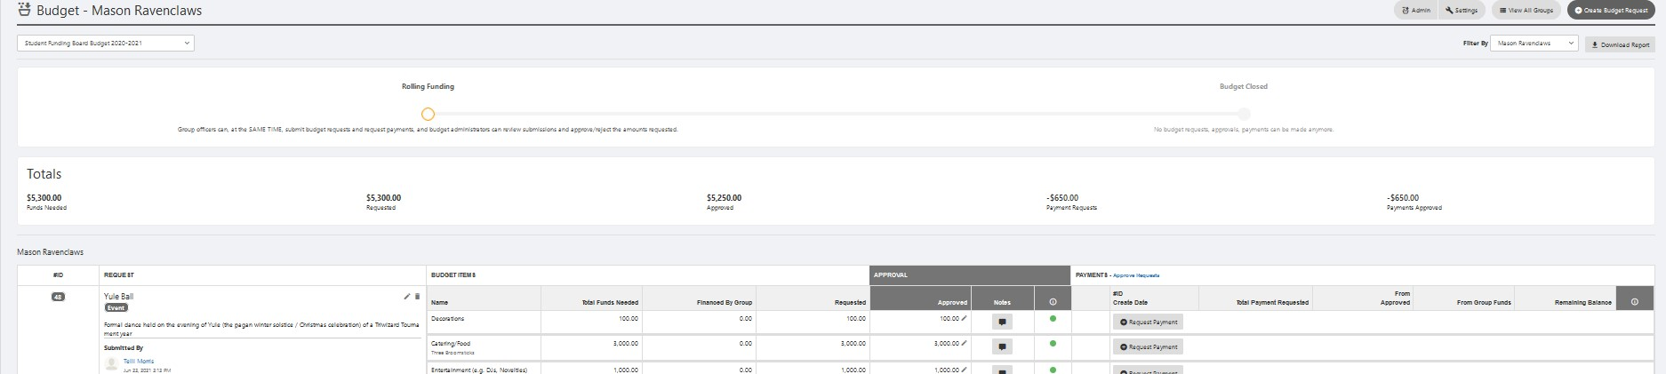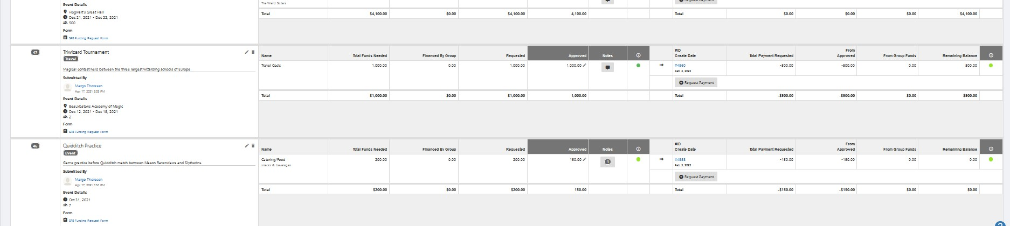

- To spend the SFB money that your RSO has been allocated for an expense or to use a combination of SFB money and SGR, click “Request Payment” next to the item.
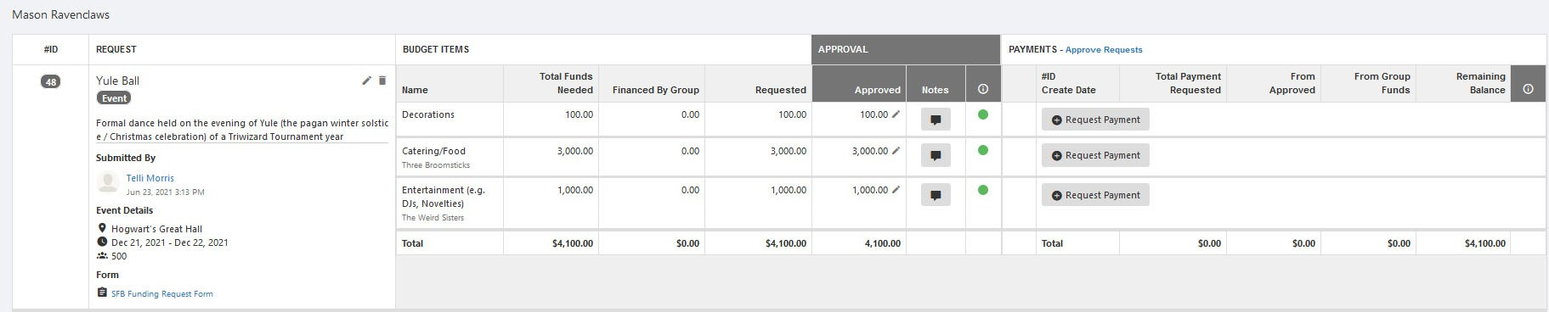

- On the pop‐up window that appears, follow the instructions and then click “Save.”
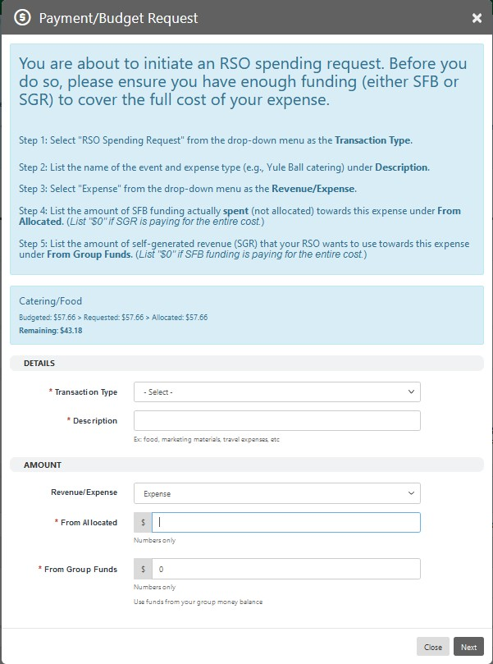

- You will be brought to the RSO Spending Request form. Select one of the spending methods
(e.g., Purchase Order / Pcard, Reimbursement, On‐Campus Charging, Honorarium, or Journal Voucher) for your expense. If you are not sure, select “I have absolutely no idea!” to answer a series of questions, which will bring you to the correct spending method.
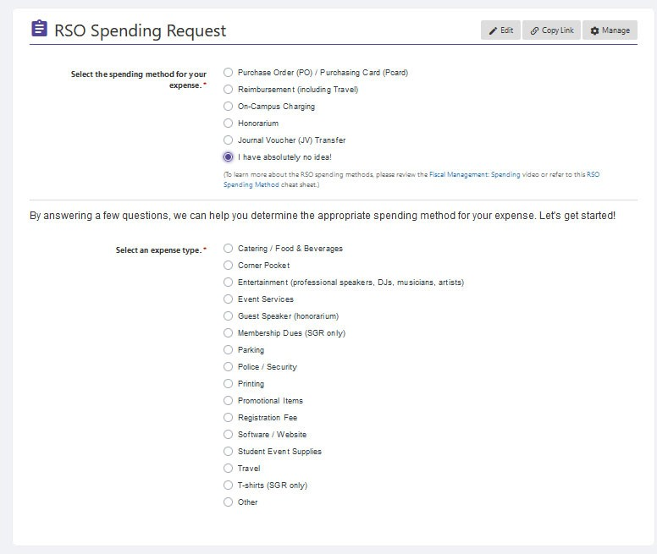

- When navigating through the form, use the “<<Back” and “Next >>” buttons (located at the bottom of the Mason360 form) instead of the internet browser’s back button.
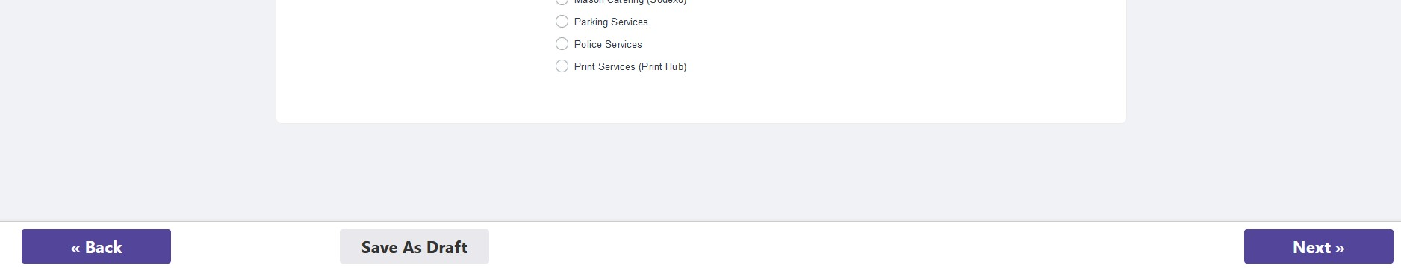

- Useful information, such as the “Purpose” of the spending method, “Instructions,” and any
“Additional Information,” is provided at the top of each spending method’s page. Please read
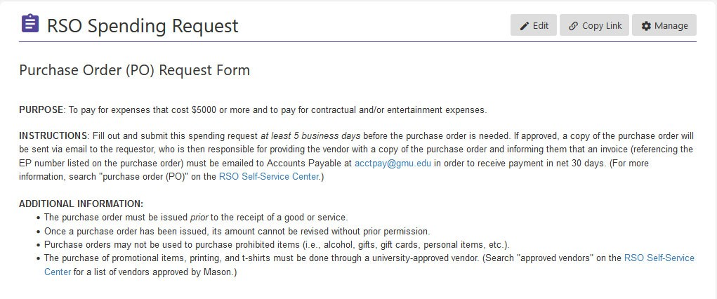
these

sections

carefully.

- After you have completed the RSO Spending Request form, click “Submit” to have it sent to the Student Involvement budget team for processing. (Exception: In the case of on‐campus charging, you don’t need to submit the form. Instead, follow the instructions listed on the page 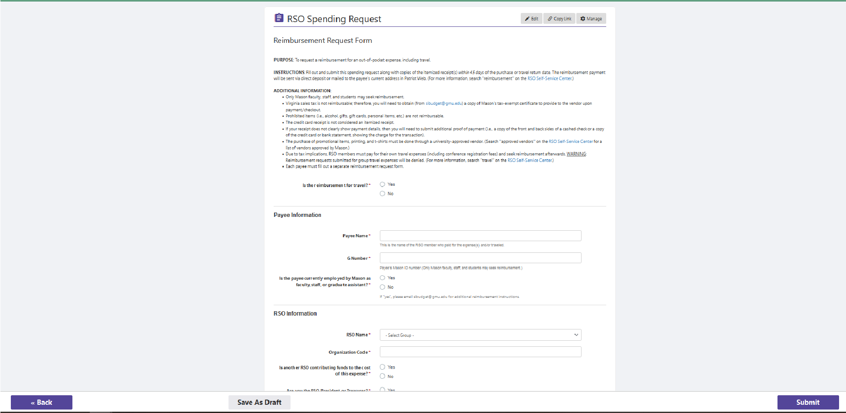to pay the on‐campus vendor.)

If you have any questions, please email <sibudget@gmu.edu>.

